|  |  |  |  |
| --- | --- | --- | --- |
| FACULTY OF ENGINEERING |  | CAIRO UNIVERSITY |  |
| 3rd Year | | | |
| Course: Electrical Power Systems (1)  (EPE3010) | | | |

|  |  |  |  |
| --- | --- | --- | --- |
| B.N. | Section | ID | Name |
| 1 | 3 | 9202929 | Omar Gamal Abd El-Hamid Zahran |
| 8 | 3 | 9202977 | Omat Mohamed Gamal Taher Nouh |
| 9 | 3 | 9202980 | Omar Mohamed Saeed Hussein |
| 33 | 3 | 9203173 | Mohamed Ashraf Mabrouk EL-Abd |
| 35 | 3 | 9203193 | Mohamed Gamal Hob El-Din Torky |
| 48 | 3 | 9203271 | Mohamed Tarek Abd El-Salam Amin |
| 54 | 3 | 9190417 | Mohamed Eid Aly Abdullah |

Project topic: Transmission line design

Instructor: Associate Professor Dr. Heba Ahmed Hassan

Date: 3/1/2023

# TABLE OF CONTENTS

TABLE OF CONTENTS 2

TABLE OF FIGURES 3

TABLE OF EQUATIONS 3

Introduction 3

Generation 4

Transmission 4

Sub-transmission Substation 4

Distribution 5

Environmental constrains 5

Mechanical constraints 5

Economical constrains 5

CALCULATION OF TRANSMISSION LINE PARAMETERS 5

Resistance 5

1. DC resistance 5

2. AC resistance 6

3. Other factors 6

4. Active power 7

Inductance 7

1. Internal inductance 7

1. External inductance 8

2. Reactance 9

Capacitance 9

1. Capacitance between phases 9

2. Capacitance to ground 9

3. Reactance 9

1. π Model 9

2. T Model 9

Conductance 9

TRANSMISSION LINE MODELLING 9

Simulation outputs 9

1. Efficiency 9

2. Voltage regulation 9

3. Power factor 9

TL models 10

Lengthwise speaking, Transmission lines are classified into three categories 10

1. Short TL (<80 km) 10

2. Medium TL (80-250 km) 10

3. Long TL (>250 km) 10

APPENDIX 10

Example 1 10

Example 2 11

11

Example 3 12

REFERENCES 12

# TABLE OF FIGURES

Figure 1 7

Figure 2 8

Figure 3 10

Figure 4 11

Figure 5 12

# TABLE OF EQUATIONS

(Equation 1) 6

(Equation 2) 6

(Equation 3) 7

(Equation 4) 7

(Equation 5) 8

(Equation 6) 8

(Equation 7) 9

# Introduction

The transmission of electrical energy does not usually raise as much interest as does its generation and utilization; consequently, we sometimes tend to neglect this important subject. This is unfortunate because the human and material resources involved in transmission are much greater than those employed in generation. Electrical energy is carried by conductors such as overhead transmission lines and underground cable. Although these conductors appear very ordinary, they possess important electrical properties that greatly affect the transmission of electrical energy. ….. In recent times, many important developments have come from extending innovations in the information and communications technology (ICT) field to the power engineering field. For example, the development of computers meant load flow studies could be run more efficiently allowing for much better planning of power systems. Advances in information technology and telecommunication also allowed for effective remote control of a power system's switchgear and generators. It is highly flexible in use as it can be converted to any desired form like mechanical, thermal, light, chemical etc. An electrical power system is made up of many components connected to form a large, complex system that is capable of generating, transmitting and distributing electrical energy over large areas.

The electric power system is defined as a large electric network that consists of three major components: generation, a high voltage transmission grid, and a distribution system. The high voltage transmission system links the generators to substations, which supply power to the user through the distribution system.

# Generation

In generating station, the fuel (coal, water, nuclear energy, etc.) is converted into electrical energy. The electrical power is generated in the range of 11kV to 25kV, which is step-up for long distance transmission. The power plant of the generating substation is mainly classified into three types, i.e., thermal power plant, hydropower plant and nuclear power plant. The generator and the transformer are the main components of the generating station. The generator converts the mechanical energy into electrical energy. The mechanical energy comes from the burning of coal, gas and nuclear fuel, gas turbines, or occasionally the internal combustion engine. The transformer transfers the power with very high efficiency from one level to another. The power transfer from the secondary is approximately equal to the primary except for losses in the transformer. The step-up transformer will reduce losses in the line which makes the transmission of power over long distances

# Transmission

The transmission substation carries the overhead lines which transfer the generated electrical energy from generation to the distribution substations. It only supplies the large bulk of power to bulk power substations or very big consumers.

The transmission lines mainly perform the two functions:

1. It transports the energy from generating stations to bulk receiving stations.
2. It interconnects the two or more generating stations.

The neighboring substations are also interconnected through the transmission lines. The transmission voltage is operating at more than 66kv and is standardized at 69kv, 115KV, 138KV, 161KV, 230KV, 345KV, 500KV, and 765KV, line-to-line. The transmission line above 230KV is usually referred to as extra high voltage (EHV). The high voltage line is terminated in substations which are called high voltage substations, receiving substations or primary substations. In high voltage substation, the voltage is step-down to a suitable value for the next part of flow toward the load. The very large industrial consumers may be served directly to the transmission system

## Sub-transmission Substation

The portion of the transmission system that connects the high voltage substations through the step-down transformer to the distribution substations is called the sub-transmission system. The sub-transmission voltage level ranges from 90 to 138KV. The sub transmission system directly serves some large industries. The capacitor and reactor are in the substations for maintaining the transmission line voltage. The operation of the sub-transmission system is like that of a distribution system. It differs from a distribution system in the following manner.

1. A sub-transmission system has a higher voltage level than a distribution system.
2. It supplies only bigger loads.
3. It supplies only a few substations as compared to a distribution system which supplies some loads.

# Distribution

The component of an electrical power system connecting all the consumers in an area to the bulk power sources is called a distribution system. The bulk power stations are connected to the generating substations by transmission lines. They feed some substations which are usually situated at convenient points near the load centers. The substations distribute the power to the domestic, commercial, and relatively small consumers. The consumers require large blocks of power which are usually supplied at sub-transmission or even transmission system

In the following we concern for transmission of power and transmission line design so to do that we must design the different parameters of the T.L like (transmission voltage, conductor type, number of circuits, and number of bundles per phase) also we should satisfied some constrains (electric, mechanical, environmental and economical constraints)

## Environmental constrains

These constraints guarantee the protection of the health of the people surrounding the transmission line if it passes near a living area

## Mechanical constraints

The different forces existing on the conductors (string and the tower)

## Economical constrains

The economical constrains is that we should achieve all the previous constrains but by using the minimum cost possible

Here we will design the transmission line according to electrical constrains only so we will focus on designing of transmission line parameters such (material of transmission line and calculations of the efficiency, voltage regulation, power factor at receiving end, current at sending / receiving end and line resistance / impedance / capacitance / inductance)

If our design don’t achieve all of the requirements and all the constrains we will try another design by change some parameters (voltage, conductor material, number of bundles or circuits per phase ) until we find the best design that achieve all the requirements (the best performance , minimum cost , …)

# CALCULATION OF TRANSMISSION LINE PARAMETERS

## Resistance

### DC resistance

The DC resistance of a transmission line defines the power losses by a DC voltage applied to the transmission line. It is almost linearly dependant on the ambient temperature. The basic equation of the DC resistance according to Ohm’s law is:

However, this version of the resistance equation is described by the voltage and current values of the line. However, the DC resistance is also described by the geometry of the conductor as follows: (Reta-Herna´ndez, 2010)

$$R=\frac{ρ*l}{A}$$

(Equation )

Where:

R: Conductor resistance

$ρ$: Conductor resistivity

l: Length

A: Cross sectional area

### AC resistance

As we start applying variable AC voltage, the resistance of the line start increasing. This is due to the skin effect caused by the AC voltage. This phenomenon was first described by Horrace Lamb in 1883 (Lamb, 1883) and could be formulated by Helmholtz equations. (CHENG, 1983)

### Other factors

There are other reasons that increase the TL resistance that arise due to other factors such as:

* Temperature: the resistance is linearly proportional to the increase in temperature. This can be described by the following equation:

$$R_{2}=R_{1}\left(\frac{T+t_{1}}{T+t_{2}}\right)$$

(Equation )

Resistance at previous temperature.

$R_{2}:$ Resistance at new temperature.

$T:$ Temperature coefficient

$t_{1}:$ Initial temperature

$t_{2}:$ Second temperature

$CITATION Man10 \backslash l 2057$ $(Reta-Herna´ndez, 2010)$

* Spiraling of stranded conductors : Stranding of a transmission line is a method used to decrease the AC losses due to the inductance of the line (This will be further described in some detail in (The inductance section). However, this slightly increases the resistance of the line due to increasing its length.
* Bundle conductors’ arrangement

### Active power

The Active power is simply put, the heat losses by the conductor due to the obstruction of the current flow. The equation for calculating the active power lost is as follows:

Figure

*(Source: Electrical-engineering-portal.com)*

$$P=I^{2}*R$$

(Equation )

## Inductance

The inductance s the ratio of the total magnetic flux flowing around a conductor to the current passing through it. (Transmission Line Parameters - What are they?, 2021) $$L=φ/I$$

(Equation )

We must deal with several factors to calculate the conductor inductance which we will further discuss in detail.

### Internal inductance

It is the internal obstruction to the change in current within the conductor due to the backward EMF induced in the conductor. According to Faraday’s law, when the current changes, a backward voltage arises which opposes this change. (Transmission Lines, 2016)

$${EMF}_{backward}=-N\frac{dφ}{dt}$$

(Equation )

Thus, when an AC voltage is supplied to our line, the backward EMF expresses itself in terms of the internal inductance. It can be described by the following equations: (Reta-Herna´ndez, 2010)

$$λ_{int}=\frac{μ_{o}}{8π}$$

(Equation )

### External inductance

If we place two wires carrying a DC current, then according to Ampere’s circuital law, the flux from each wire will oppose each other. Practically speaking, we can deal with this phenomenon (defined as mutual induction between two currents carrying conductors) by either increasing the separating distance between them or by using a separating medium with low magnetic permeability which hinders the flow of magnetic flux from one wire to another.

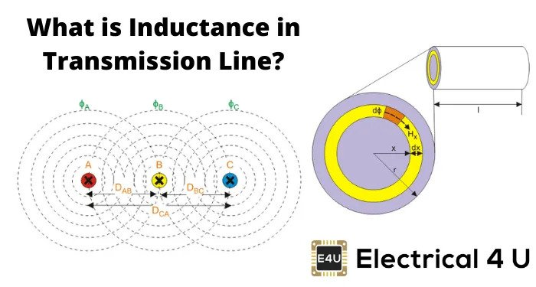

Figure

*(Source: Electrical4U.com)*

The external inductance depends on the strands’ arrangement and depends on two factors:

1. Geometric mean radius
2. Geometric mean distance (Concept of GMD and GMR, 2016)

The final inductance due to the external effect of the neighbouring strands is as follows:

(Reta-Herna´ndez, 2010)

### Reactance

It is the total opposition of the magnetic properties of the transmission line due to the change in current.

$$X_{L}=ωL_{ct}$$

(Equation )

## Capacitance

The capacitance of the transmission line is because the conductors are separated from each other and from earth by air or any dielectric. This causes some leakage current from the line and can affect the voltage regulation as the receiving end voltage is higher than the sending end voltage. This is called Ferranti effect, and it is limited by using shunt compensators as well as other types of transmission line control methods. (Transmission Lines, 2016) The line capacitance can be neglected for short lengths or if the conductors are spaced widely enough.

### Capacitance between phases

Since each phase is separated from its neighbour by an insulator (formally known as: dielectric), there is a capacitance formed between the two phases. Thus, a leakage current passes between the phases and forms what is known as a line capacitance. (Transmission Line Parameters - What are they?, 2021)

### Capacitance to ground

This form of capacitance arises between the line and the ground beneath it.

### Reactance

Again, as we said, the line capacitance can be neglected when the line is short (Electrical4U, 2020). If the line is medium or long, the capacitance is either represented by one of the two following models -which we will discuss as we move onto the modelling section-:

### π Model

### T Model

## Conductance

It is the flow of current from the line to the surrounding earth. It is governed by air conditions.

# TRANSMISSION LINE MODELLING

## Simulation outputs

The program calculates the efficiency, voltage regulation, and power factor, receiving end power and voltage. Here we discuss the governing equations as well as examples of the program operation.

### Efficiency

It is the ratio of the load active power to the source active power. It is affected by the losses due to the parameters discussed above.

### Voltage regulation

It is the ratio between the difference between the sending and receiving end voltages to the sending end voltage.

### Power factor

It is the ratio between the active power transmitted to the apparent power.

## TL models

### Lengthwise speaking, Transmission lines are classified into three categories

### Short TL (<80 km)

The line capacitance is small enough to be neglected. Typically, the operational voltage level is less than 69kV.

### Medium TL (80-250 km)

The line capacitance is not neglected and is modelled as either T or π model. Typically, the operational voltage level is between 69kV and 133kV.

### Long TL (>250 km)

Same as the medium model The line capacitance is not neglected and is modelled as either T or π model. Typically, the operational voltage level is more than 133kV.

# APPENDIX

This section shows some examples using the program and the outputs displayed therein.

## Example 1

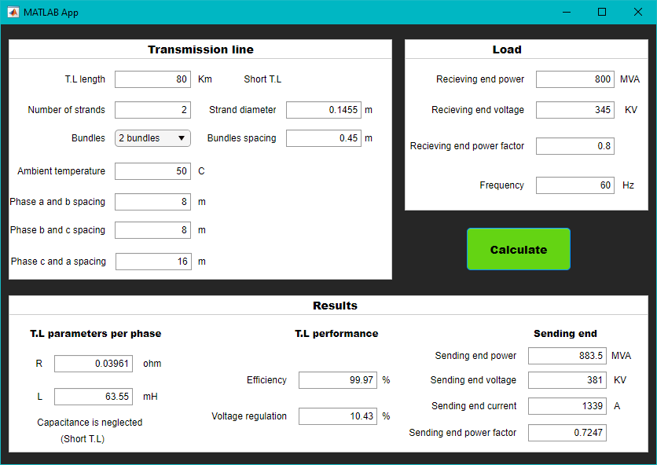

Figure

## Example 2

## 

Figure

## Example 3

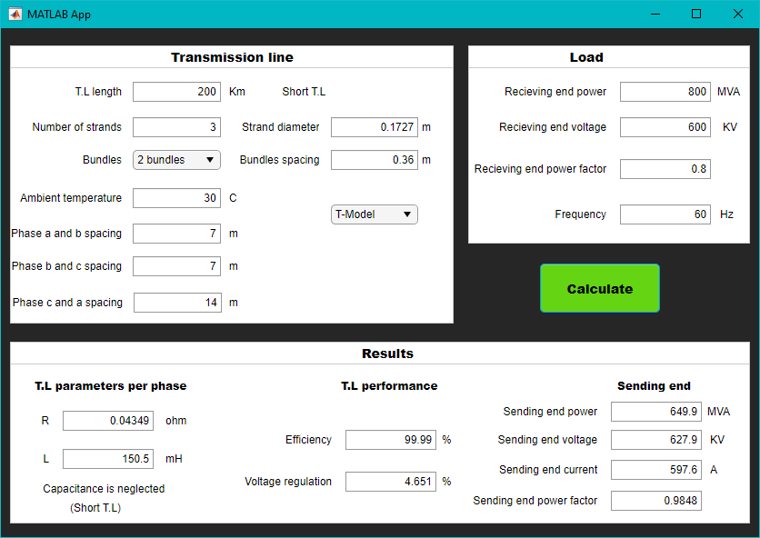

Figure

# REFERENCES

CHENG, D. K. (1983). Field and wave electromagnetics. In D. K. CHENG, *Field and wave electromagnetics* (pp. 306-369). New York: ADDISON-WESLEY.

*Concept of GMD and GMR*. (2016, September 20). Retrieved from Electrical Concepts: Concept of GMD and GMR

Electrical4U. (2020, October 28). *Transmission Lines: Parameters, Types And Theory*. Retrieved from Electrical4U: https://www.electrical4u.com/transmission-line-in-power-system/

Lamb, H. (1883). XIII. On electrical motions in a spherical conductor. *Royal Society*, 519–549. doi:https://doi.org/10.1098/rstl.1883.0013

Reta-Herna´ndez, M. (2010, September 15). *Power System Stability & Control.* Retrieved from University of Oviedo: https://www.unioviedo.es/pcasielles/uploads/proyectantes/cosas_lineas.pdf

*Transmission Line Parameters - What are they?* (2021, August 1). Retrieved from Electrical Deck: https://www.electricaldeck.com/2021/08/transmission-line-parameters.html

*Transmission Lines*. (2016, June 24). Retrieved from Circuit Globe: https://circuitglobe.com/transmission-lines.html